**ABOUT THE DATASET**

The Social­_Network provides insight into the relationship between the Age and the estimated Salary of those who can purchase and those who cannot purchase a particular item based on their income.

The dataset comprises of 400 data point (rows) and feature 3 informative columns: ‘Age, Estimated Salary and purchased . It offers a comprehensive statistics view of their cost of living. Below is the first 5 rows of the dataset.

|  |  |  |  |
| --- | --- | --- | --- |
| S/N | Age | Estimated Salary | Purchased |
| 0 | 19.0 | 19000.0 | 0.0 |
| 1 | 35.0 | 20000.0 | 0.0 |
| 2 | 26.0 | 43000.0 | 0.0 |
| 3 | 27.0 | 57000.0 | 0.0 |
| 4 | 19.0 | 76000.0 | 0.0 |

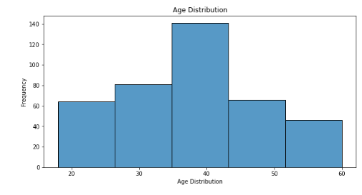

This chart above provides a visualization of the distribution of age in the dataset which show that the highest was about 40 which have the highest frequency as well.

It also shows that the people between the ages of 50 and 20 has almost the same achievement while people in the early 50 to 60 have the lowest achievements.

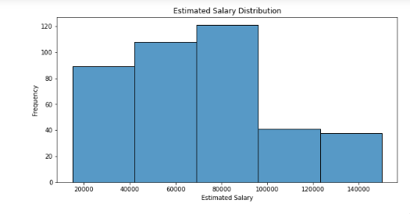

The chart above show the distribution of estimated salary. Which shows that people with the highest estimated salary is 80000, follow by 6000 to 2000 and people with the estimated salary of about 100,000 to 140,000 which is the highest amount of salary and has the fewer number of persons which may fall under the Directors list.

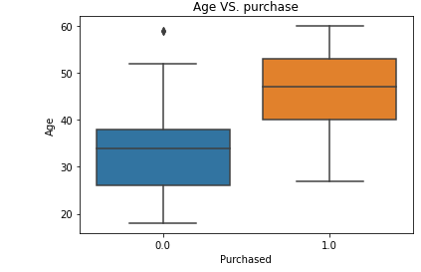

The box chart above shows the correlation between age and purchased.

This Distribution shows that persons between the age of 25 to 38 purchased items while persons between the age of 40 to 55 could not made purchase which may probably be because of the salary range .

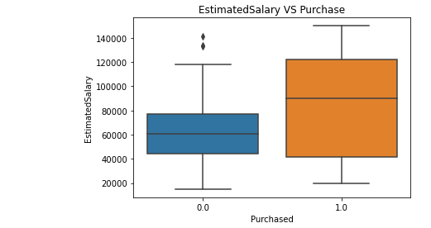

The box chart above shows the relationship between estimated salary and purchased

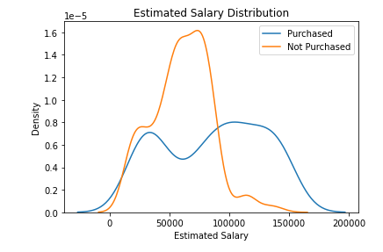

This visual shows the trend of salary Distribution.

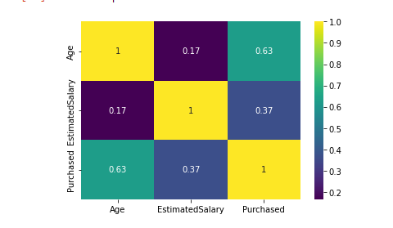

This heat map show the correlation of Age, Estimated salary and Purchased.

The dripper the color lesser the relationship and the lighter the color the closer the relationship.